**DAILY ONLINE ACTIVITIES SUMMARY**

|  |  |  |  |  |  |  |  |
| --- | --- | --- | --- | --- | --- | --- | --- |
| **Date:** | **18/05/2020** | | | | **Name:** | **Churashma** | |
| **Sem & Sec** | **4th SEM SECTION 'A'** | | | | **USN:** | **4AL18CS019** | |
| **Online Test Summary** | | | | | | | |
| **Subject** | | **Complex analysis, Probability and Statistical methods(18MAT41)** | | | | | |
| **Max. Marks** | | **30** | | **Score** | | **Not yet declared** | |
| **Certification Course Summary** | | | | | | | |
| **Course** | **CLOUD FOUNDATION** | | | | | | |
| **Certificate Provider** | | | **GREAT LEARNING ACADEMY** | **Duration** | | | **1.5 hours** |
| **Coding Challenges** | | | | | | | |
| **Problem Statement 1:** Given an array of distinct integers .The task is to count all the triplets such that sum of two elements equals the third element**. Problem Statement 2:** Write a C program to check whether the two strings are Anagram or not.  **Problem Statement 2:** Write a C program to check whether the two strings are Anagram or not. | | | | | | | |
| **Status: executed** | | | | | | | |
| **Uploaded the report in Github** | | | | **Yes** | | | |
| **If yes Repository name** | | | | **https://github.com/Churashma/Lockdown-coding** | | | |
| **Uploaded the report in slack** | | | | **Yes** | | | |

**Online Test Summary**: 18MAT41 test was scheduled from 9:30 am t0 10 am And the test scores are not yet received .The portion for the IA was 4th module there were 30 questions and the time assigned was 30 minutes the questions were mcq type.

**Online Certification course Summary**: I have opted my Online Certification Course in Greatlearning academy the course which I have opted is **Cloud foundation**.

**About this course**

In this course, you will be introduced to the basic concepts of cloud computing and become familiar with the history and evolution of cloud computing. Further in the course, you will also get introduced to virtualization and its correlation with cloud computing. You will also get a good understanding of virtualization basics and how VMs compare to containers.

**1.Skills covered**

• Cloud basics

• Deployment Models

• IT vs Cloud

**2.Course Syllabus**

• Cloud Foundations

• Intro to Cloud Computing

• Cloud Computing Attributes and offerings

• Pricing and scaling models

• Introduction to Virtualization

• Container vs VM Virtualization

• Price Economics & Decision Making

• Apps for Cloud & Security Model

• Infrastructure Automation, IOT and more

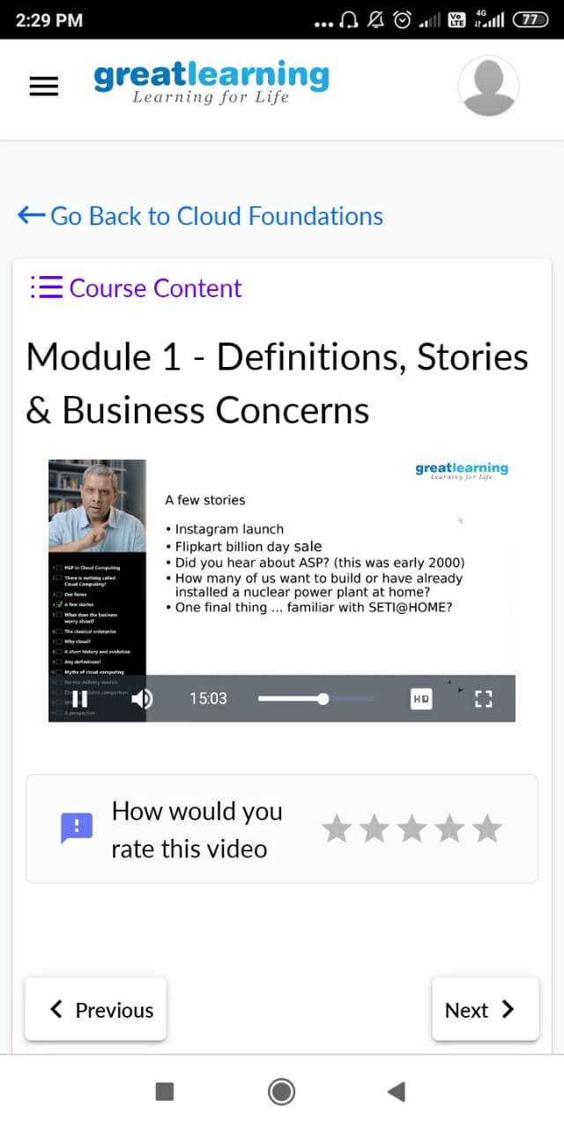

.

**CODING CHALLENGES DETAILS**:

**Problem statement 1:**

Given an array of distinct integers. The task is to count all the triplets such that the sum of two elements equals the third element.

So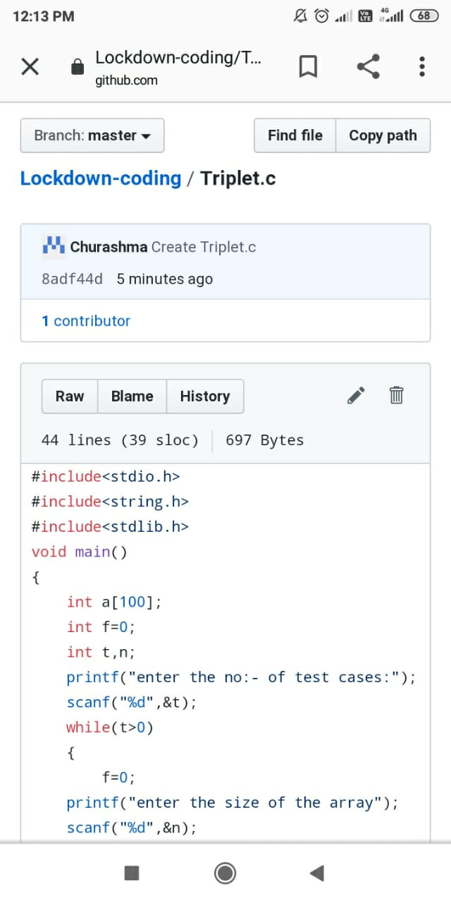lution: Uploaded in github.

**Problem statement 2:**

Write a C Program to check whether the two string are Anagram or not.

Hint: An Anagram of a string is another string that contains same characters, only the order of characters can be different.  
For example, "act" and "cat" are anagram of each other.

Solution: Uploaded in github.

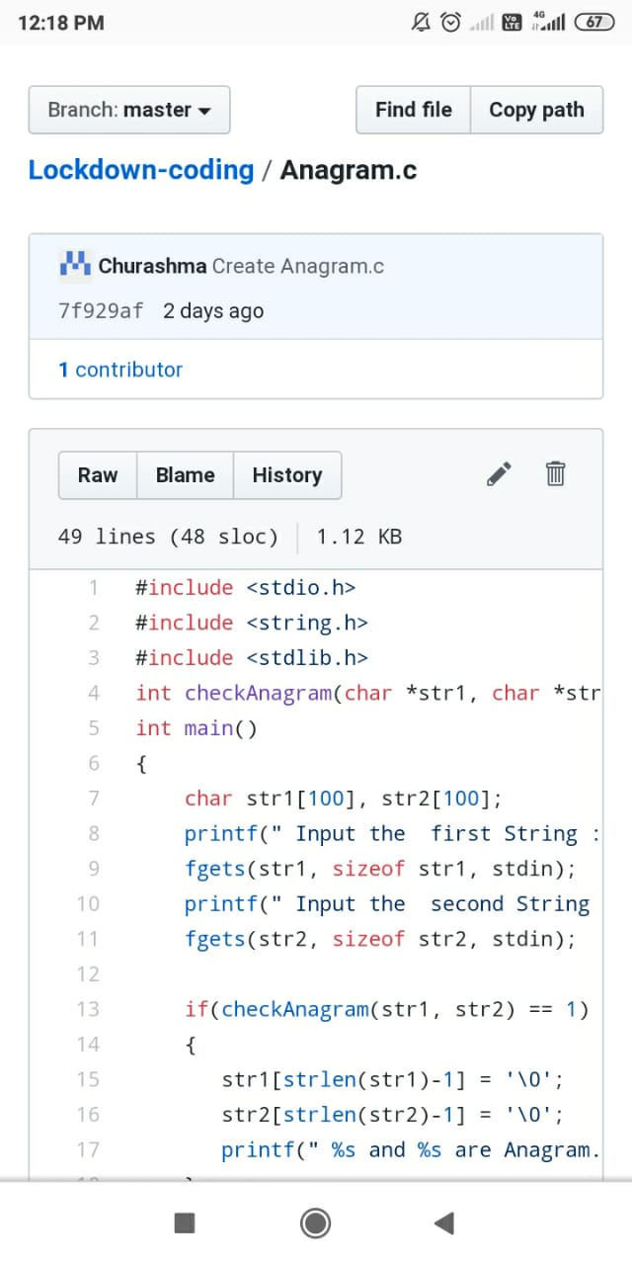

**Problem statement 3:**

Using methods charAt() & length() of String class, write a program to print the  
frequency of each character in a string.  
“Hello friend”

Output should be  
-: 1  
d: 1  
e: 2  
f: 1  
(continued for all character in the string)

Solution : Uploaded in github.

